Agile software development refers to software development methodologies centered around the idea of iterative development, where requirements and solutions evolve through collaboration between self-organizing cross-functional teams. The ultimate value in Agile development is that it enables teams to deliver value faster, with greater quality and predictability, and greater aptitude to respond to change. Scrum and Kanban are two of the most widely used Agile methodologies. Below are the most frequently asked questions around Agile and Scrum, answered by our experts.

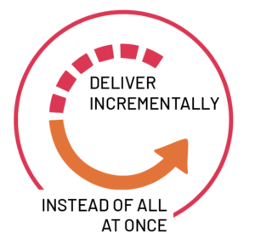

**Agile software**

Agile software development refers to a group of software development methodologies based on iterative development, where requirements and solutions evolve through collaboration between self-organizing cross-functional teams. Agile methods or Agile processes generally promote a disciplined project management process that encourages frequent inspection and adaptation, a leadership philosophy that encourages teamwork, self-organization and accountability, a set of engineering best practices intended to allow for rapid delivery of high-quality software, and a business approach that aligns development with customer needs and company goals. Agile development refers to any development process that is aligned with the concepts of the Agile Manifesto. The Manifesto was developed by a group of fourteen leading figures in the software industry, and reflects their experience of what approaches do and do not work for software development.

**Scrum**

Scrum is a subset of Agile. It is a lightweight process framework for agile development, and the most widely-used one.

* A “process framework” is a particular set of practices that must be followed in order for a process to be consistent with the framework. (For example, the Scrum process framework requires the use of development cycles called Sprints, the XP framework requires pair programming, and so forth.)
* “Lightweight” means that the overhead of the process is kept as small as possible, to maximize the amount of productive time available for getting useful work done.

A [Scrum process](https://www.cprime.com/2015/03/5-tips-to-manage-scrum-processes-in-the-real-world/) is distinguished from other agile processes by specific concepts and practices, divided into the three categories of Roles, Artifacts, and Time Boxes. These and other terms used in Scrum are defined below. Scrum is most often used to manage complex software and product development, using iterative and incremental practices. Scrum significantly increases productivity and reduces time to benefits relative to classic “[waterfall](https://www.cprime.com/2011/01/integrating-waterfall-and-agile-development-hybrid-model/)” processes. Scrum processes enable organizations to adjust smoothly to rapidly-changing requirements, and produce a product that meets evolving business goals. An agile Scrum process benefits the organization by helping it to

* Increase the quality of the deliverables
* Cope better with change (and expect the changes)
* Provide better estimates while spending less time creating them
* Be more in control of the project schedule and state

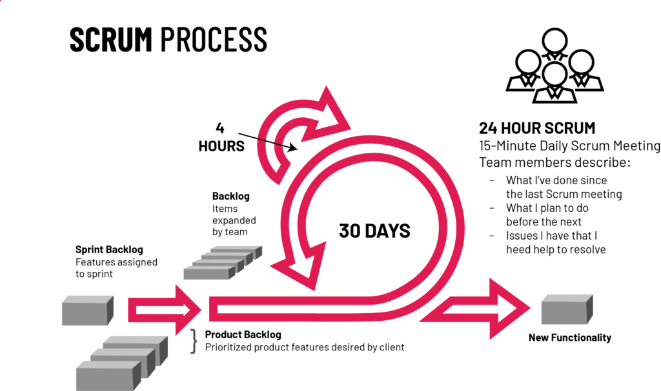

What are the benefits of Agile?

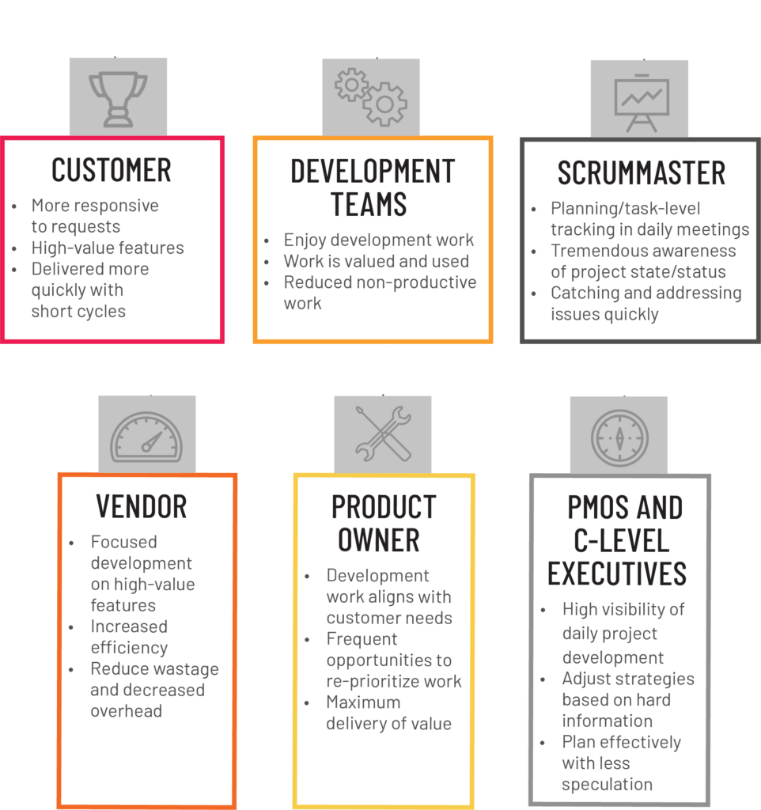

Benefits to Customer

Customers find that the vendor is more responsive to development requests. High-value features are developed and delivered more quickly with short cycles, than with the longer cycles favored by classic “waterfall” processes.

Benefits to Vendors

Vendors reduce wastage by focusing development effort on high-value features, and reduce time-to-market relative to waterfall processes due to decreased overhead and increased efficiency. Improved customer satisfaction translates to better customer retention and more positive customer references.

Benefits to Development Teams

Team members enjoy development work, and like to see their work used and valued. Scrum benefits Team members by reducing non-productive work (e.g., writing specifications or other artifacts that no one uses), and giving them more time to do the work they enjoy. Team members also know their work is valued, because requirements are chosen to maximize value to customers.

Benefits to Product Managers

Product Managers, who typically fill the Product Owner role, are responsible for making customers happy by ensuring that development work is aligned with customer needs. Scrum makes this alignment easier by providing frequent opportunities to re-prioritize work, to ensure maximum delivery of value.

Benefits to Project Managers

Project Managers (and others) who fill the ScrumMaster role find that planning and tracking are easier and more concrete, compared to waterfall processes. The focus on task-level tracking, the use of Burndown Charts to display daily progress, and the Daily Scrum meetings, all together give the Project Manager tremendous awareness about the state of the project at all times. This awareness is key to monitoring the project, and to catching and addressing issues quickly.

Benefits to PMOs and C-Level Executives

Scrum provides high visibility into the state of a development project, on a daily basis. External stakeholders, such as C-Level executives and personnel in the Project Management Office, can use this visibility to plan more effectively, and adjust their strategies based on more hard information and less speculation